**ACADEMIC HONESTY POLICY**



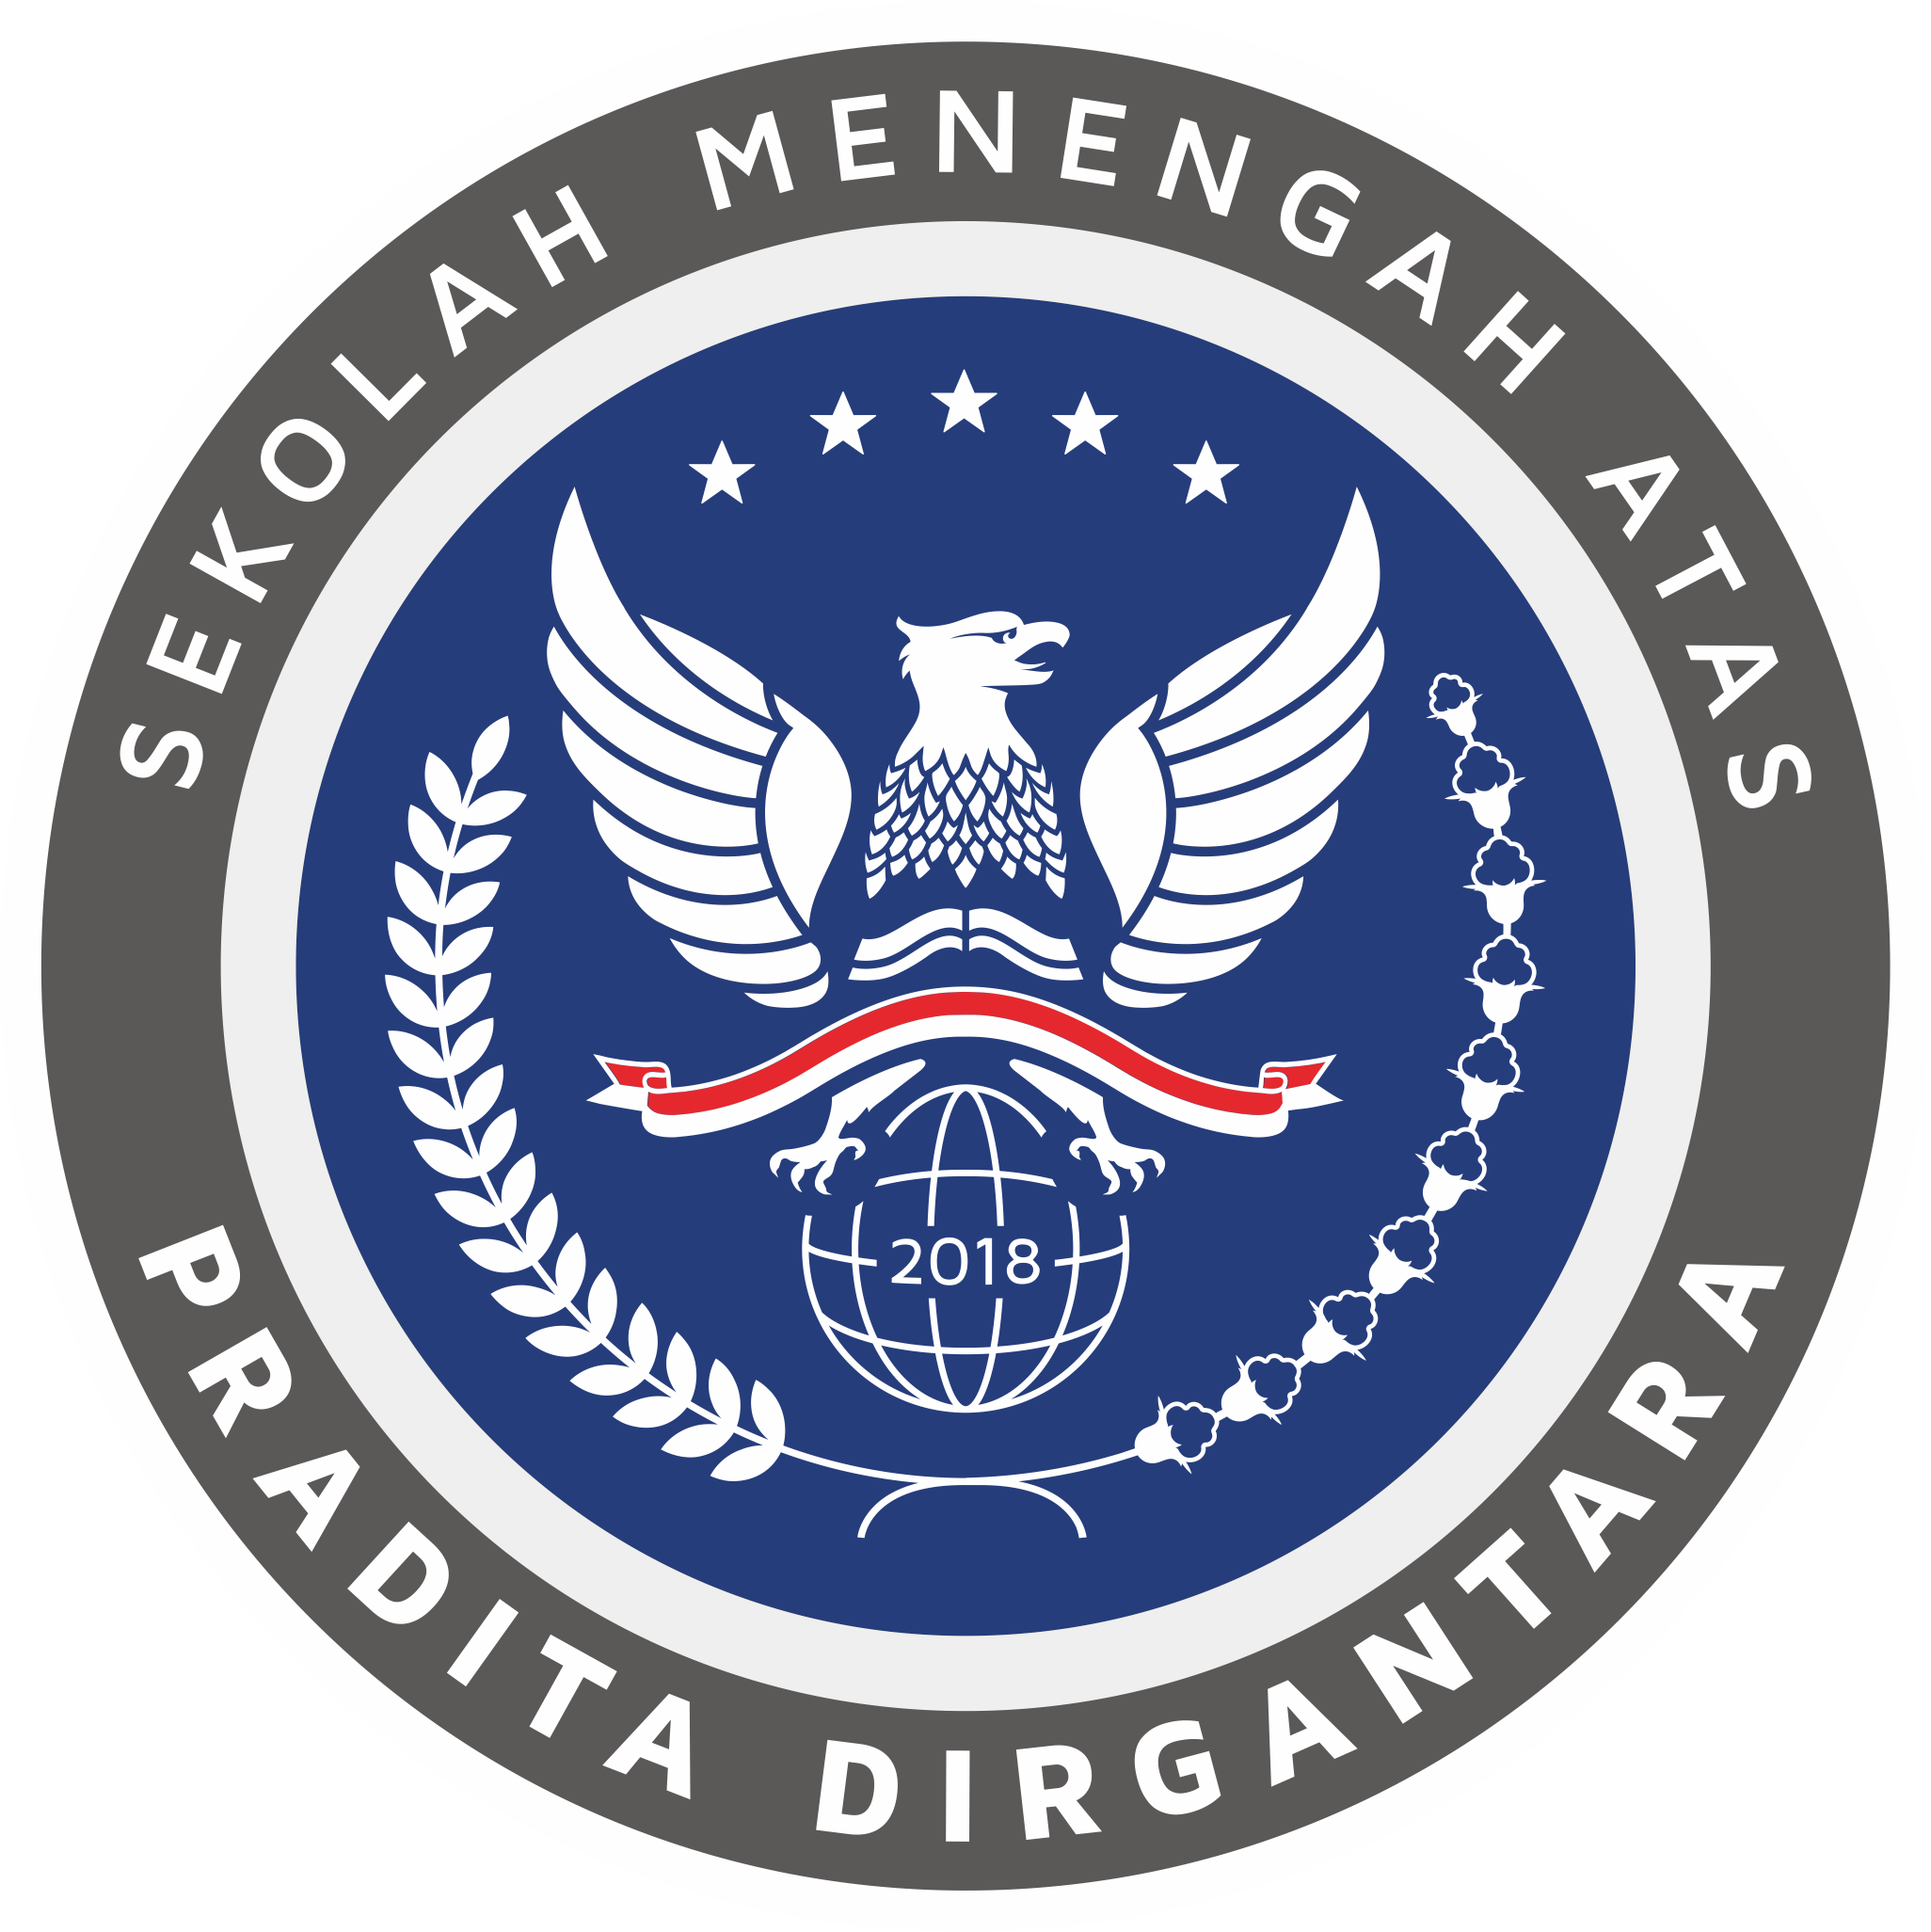

**SMA PRADITA DIRGANTARA**

**2021-2022**

**THE IB MISSION STATEMENT**

The International Baccalaureate aims to develop inquiring, knowledgeable and caring young people who help to create a better and more peaceful world through intercultural understanding and respect. To this end the organization works with schools, governments and international organizations to develop challenging programmes of international education and rigorous assessment. These programmes of international education encourage students across the world to become active, compassionate and lifelong learners who understand that other people, with their differences, can also be right.

**THE IB LEARNER PROFILE** **1n** (School/individual)

|  |  |
| --- | --- |
| The aim of all IB programmes is to develop internationally minded people who, recognizing their common humanity and shared guardianship of the planet, help to create a better and more peaceful world.  IB learners strive to be: | |
| Inquirers | They develop their natural curiosity. They acquire the skills necessary to conduct inquiry and research and show independence in learning. They actively enjoy learning and this love of learning will be sustained throughout their lives. |
| Knowledgeable | They explore concepts, ideas and issues that have local and global significance. In so doing, they acquire in-depth knowledge and develop understanding across a broad and balanced range of disciplines. |
| Thinkers | They exercise initiative in applying thinking skills critically and creatively to recognize and approach complex problems, and make reasoned, ethical decisions. |
| Communicators | They understand and express ideas and information confidently and creatively in more than one language and in a variety of modes of communication. They work effectively and willingly in collaboration with others. |
| Principled | They act with integrity and honesty, with a strong sense of fairness, justice and respect for the dignity of the individual, groups and communities. They take responsibility for their own actions and the consequences that accompany them. |
| Open-minded | They understand and appreciate their own cultures and personal histories, and are open to the perspectives, values and traditions of other individuals and communities. They are accustomed to seeking and evaluating a range of points of view, and are willing to grow from the experience. |
| Caring | They show empathy, compassion and respect towards the needs and feelings of others. They have a personal commitment to service, and act to make a positive difference to the lives of others and to the environment. |
| Risk-takers | They approach unfamiliar situations and uncertainty with courage and forethought, and have the independence of spirit to explore new roles, ideas and strategies. They are brave and articulate in defending their beliefs. |
| Balanced | They understand the importance of intellectual, physical and emotional balance to achieve personal well-being for themselves and others. |
| Reflective | They give thoughtful consideration to their own learning and experience. They are able to assess and understand their strengths and limitations in order to support their learning and personal development. |

_____

1 EFFECTIVE CITING AND REFERENCING, IBO, 2014

**SMA PRADITA DIRGANTARA MISSION STATEMENT**

To be a secondary education institution that has a reputation at the international level by always upholding the national culture to produce faithful, intelligent, creative, active, compassionate and lifelong learners, independent future leaders who have aerospace comprehension.

**SMA PD ACADEMIC HONESTY PHILOSOPHY**

At SMA Pradita Dirgantara we place great value on personal integrity and academic honesty. The administration and staff strongly believe that integrity must be a significant component in the academic success of our students; therefore, we promote academic honesty throughout their scholastic years at SMA Pradita Dirgantara by fostering the traits outlined in the IB Learner Profile and in particular the following:

* PRINCIPLED

We act with integrity and honesty, with a strong sense of fairness and justice, and with respect for the dignity and rights of people everywhere. We take responsibility for our actions and their consequences.

* THINKERS

We use critical and creative thinking skills to analyze and take responsible action on complex problems. We exercise initiative in making reasoned, ethical decisions.

Academic Honesty is in line with the IBO Approaches to learning.

Through:

* Self-management
* Social
* Communication
* Thinking
* Research

students develop skills that will allow to learn and be responsible of their learning.

**UNDERSTANDING AND PROMOTING ACADEMIC HONESTY AT SMA PD**

Academic honesty and integrity are the foundation of any educational institutions. The IB upholds principles of academic honesty, which are seen as a set of values and skills that promote personal integrity and good practice in teaching, learning and assessment. Promoting Academic Honesty is essential because lack of academic integrity undermines the philosophy of any educational programme. Students engaging in academic misconduct miss the “learning opportunity”. Moreover, those who breach the regulations of academic work will find it easy to contravene the conventions in other fields. All stakeholders in the SMA PD community believe that the principle of academic honesty should be considered by students as a learning experience and become part of their academic study during and beyond the IB Diploma course of study. 2

_____

2 ACADEMIC HONESTY — PRINCIPLES TO PRACTICE

**ACADEMIC HONESTY AT SMA PD REFERS TO:**

* Undertaking research honestly and producing authentic pieces of work
* Always respecting intellectual property by acknowledging all ideas and work of others. Source materials may include along with written texts, visual, audio, graphics, artistic, letters, lectures, interviews, broadcasts, maps. Forms of intellectual property include patents, trademarks, moral right, copyrights
* Showing proper conduct during examinations

**WHAT IS MALPRACTICE?**

“The IBO defines malpractice as behavior that results in, or may result in, the candidate or any other candidate gaining an unfair advantage in one or more assessment components”. 3

Students can incur in the following forms of malpractice:

* Plagiarism: this is defined as the representation, intentionally or unwittingly, of the ideas, words or work of another person without proper, clear and explicit acknowledgment
* Collusion: this is defined as supporting malpractice by another candidate, as in allowing one’s work to be copied or submitted for assessment by another
* Duplication of work: this is defined as the presentation of the same work for different assessment components and/or diploma requirements
* Paraphrasing: this is defined as the restatement of someone’s work in another form. In order for it to be allowed, the source needs to be acknowledged
* Fabrication of data: this is defined as manufacturing data for an experiment and for mathematical exploration/project
* Disregarding the IB DP Examination Code of Conduct: this is defined as an infraction or disregard of guidelines as established by the IBO with respect to examination conduct
* Disclosing information to another candidate, or receiving information from another candidate, about the content of an examination paper within 24 hours after the examination 4

**EXAMPLE OF MALPRACTICE**

* Submitting to IBO someone else's work
* Copying the work of another candidate
* Allowing a peer to copy your work
* Not acknowledging sources
* Asking another person to write your work
* Falsifying data used in an assignment
* Falsifying CAS records and journals
* Stealing examination material and/or exam papers
* Bringing unauthorized material into the examining room. Examples: notes, unauthorized software on a graphic calculator, cell phones
* Disrupting behavior during exams » Impersonating another candidate

_____

3 GENERAL REGULATION: DIPLOMA PROGRAMME, 2014

4 ACADEMIC HONESTY GUIDE, IBO, 2009

**CONCEQUENCES OF MALPRACTICE**

At SMA PD any instance of academic dishonesty is to result in:

**First Offense**

An automatic zero for the work in the case of a ***first offence***. No opportunity is to be given to make up the zero grade. The document is to be collected by the teachers and filed with the Principal. Parents are to be notified;

**Second Offense**

An automatic zero for the work with the same above specified notifications and qualifications for a ***second offence***. Additionally, a two-day out of school suspension is to be assigned and a meeting of the Parents, student, teacher and Guidance Counselor called by the DP Coordinator. All work undertaken during the out of school suspension shall be given a grade of zero;

**Third Offense**

Indefinite suspension pending a recommendation for expulsion for a **third offence** with a grade zero being assigned to all work.

**HOW TO AVOID MALPRACTICE**

**THE ROLE OF THE DP COORDINATOR**

* Establish an academic honesty policy.
* Provide teachers with effective training opportunities.
* Ensure teachers and students adhere to the school’s academic honesty policy.
* Share with legal guardians the aim of the academic honesty policy.
* Ensure everybody understands academic honesty and consequences for IB students if they engage in academic misconduct. 5

**THE ROLE OF THE LIBRARIAN**

The Librarian has a key role in helping students become familiar with the research process and teach them the fundamentals of academic honesty. The Librarian provides guidance to students throughout their scholastic path and is a valuable resource in conducting teaching and learning of specific conventions accepted in a community of learners.

_____

5 ACADEMIC HONESTY — PRINCIPLES TO PRACTICE

**THE ROLE OF TEACHERS**

At SMA PD teachers are expected to:

* Talk to students about plagiarism and how to properly conduct a research paper or prepare an oral presentation
* Set clear expectations for assignments and provide guidance to candidates on how to correctly cite sources
* Be vigilant for changes in writing style, and in noticing that the student’s work is too complex and academic and goes beyond the student’s ability
* Read the final version and check for authenticity of any work submitted to IBO. (EE, TOK papers, Internal Assessment)
* Teachers are strongly encouraged to make use of *Plagiarism Checker* when checking on major IB assignments
* Although the candidate is ultimately responsible for ensuring that all work submit ted for assessment is authentic, with the work or ideas of others fully and correctly acknowledged, it is the responsibility of each teacher to confirm that, to the best of his or her knowledge, all candidates’ work accepted or submitted for assessment is the authentic work of each candidate. » Be role models of academic honesty and integrity

**THE ROLE OF PARENTS**

At SMA PD we strongly believe in the open communication between teachers, school administration and parents. Parents can play a very important role in supporting and helping their children achieve their full potentials and acting with honesty by:

* Read and become familiar with the Academic Honesty Policy and all IBO documents related to the IB Diploma rules and regulations
* Supporting teachers and administrations in talking to their children about the importance of academic integrity
* Cooperate with the school in case their child is found to be guilty of malpractice either intentionally, or by inappropriate documentation of sources.

**ACKNOWLEDGMENT**

This is the possible Academic Honesty Policy draft that I make in order to fulfil the learning engagement 3 of module 2. I adapted this from several sources, especially American School of Milam / ASM

(file:///Users/mandiri2/Documents/Academic_Honesty_Policy.pdf)

Our school will ask permission to the school before finalize the draft and publish the document.

**References and Resources**

Academic Honesty, IBO, 2009

Academic Honesty in the International Context, IBO 2014

Academic honesty – principles to practice

Dr. Celina Garza – IB Academic honesty manager IB Assessment Centre - Cardiff . IBO AEM General Conference, Rome 2014

Effective citing and referencing, IBO 2014

General Regulations: Diploma Program, IBO, 2011

Handbook of Procedures for the Diploma Program, IBO 2013

Reviewed by: Dwi A. Yuliantoro, Ph.D. (Head of School)

Oscar Y. Carascalao, M.Pd. (DP Coordinator)

All teachers and staff

Date of Review: November 2020

Next Review Due on: February 2021